ACF Lab 1: Introduction to AWS IAM

____________________________________________________

COS 20019- Cloud Computing Architecture

Nguyen Manh Dung

17/6/2023

So this is screenshotted for ACF Lab 1, with detailed explanation:

**Task 1: Explore the Users and Groups**

**IAM Overview**

**Permissions Overview**

**Task 2: Add Users to Groups**

1. **Add user-1 to the S3-Support Group**

1. **Add user-2 to the EC2-Support Group**

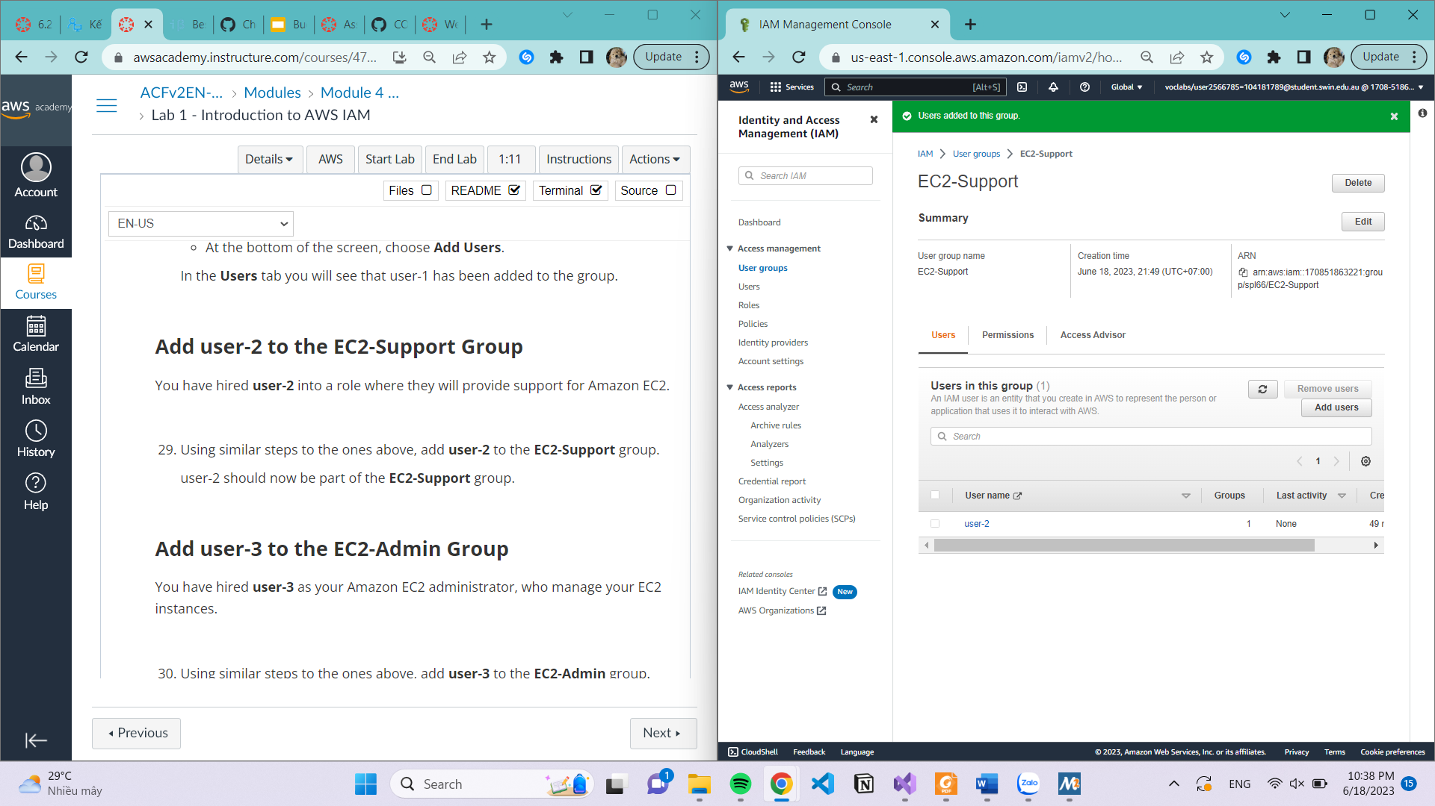

1. **Add user-3 to the EC2-Admin Group**

**Task 3: Sign-In and Test Users**

1. **Open private window and sign in as user-1**

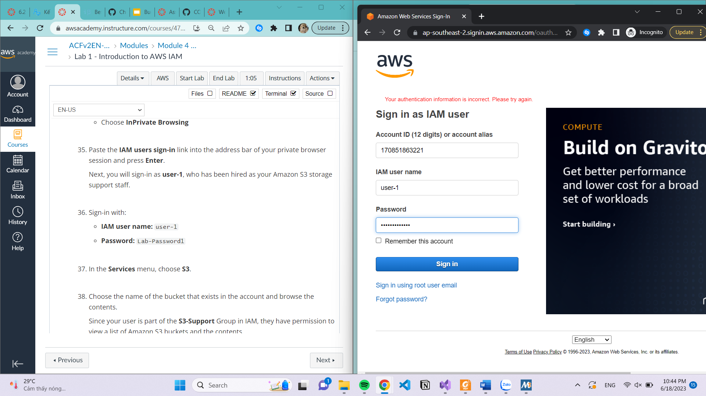

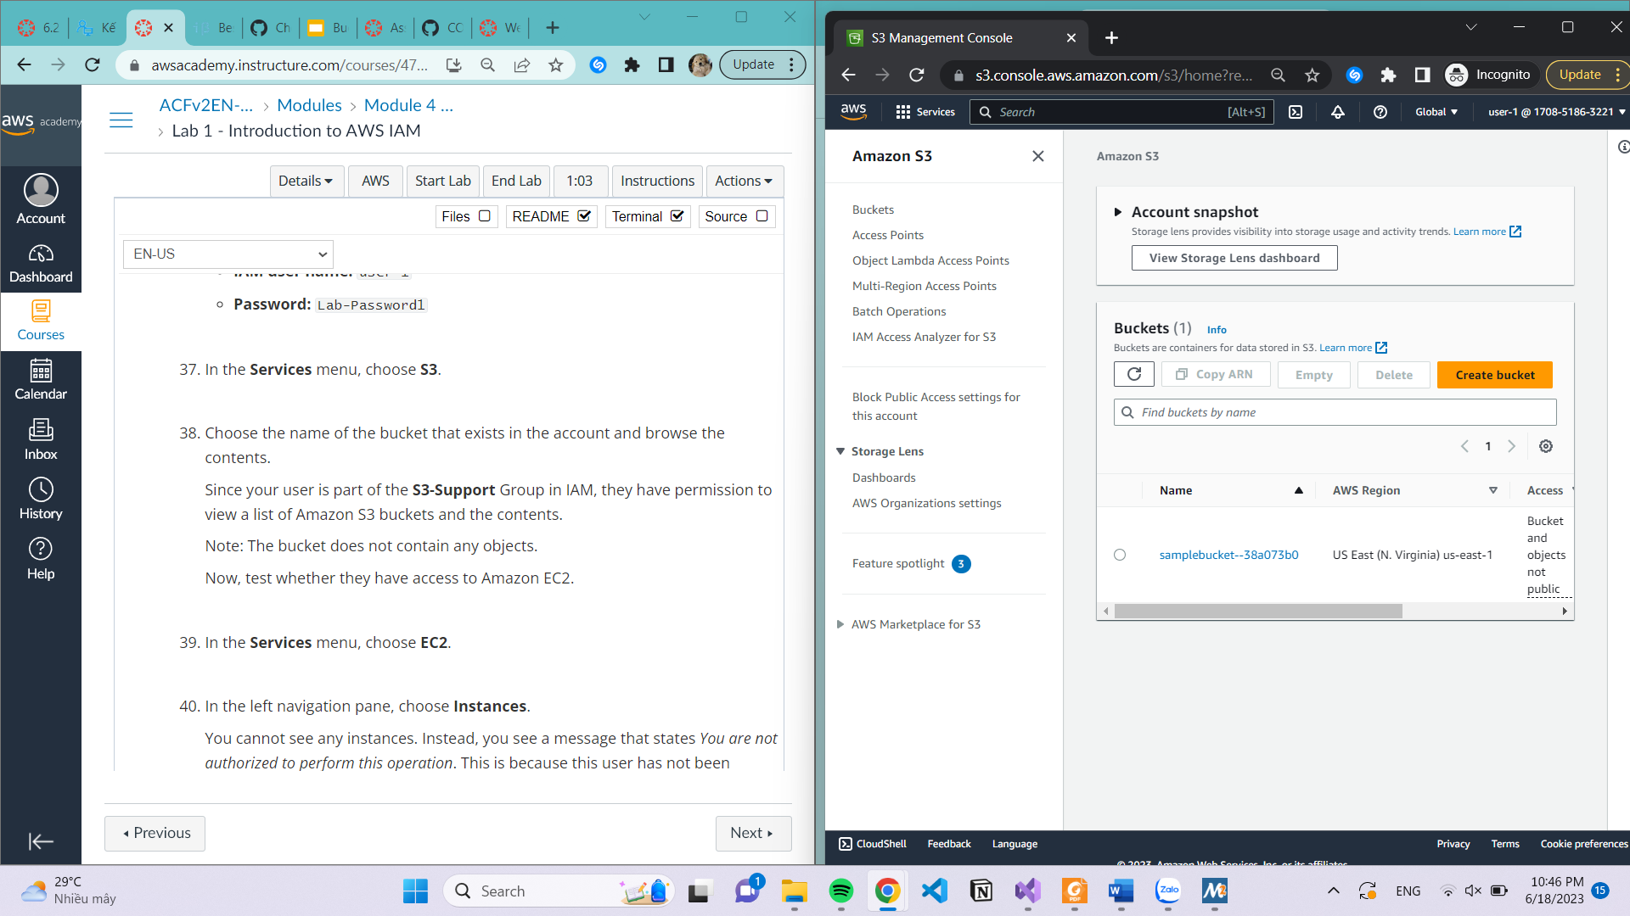

1. **Sign in as user-2 to view EC2 instance**

**Cannot Stop an instance**

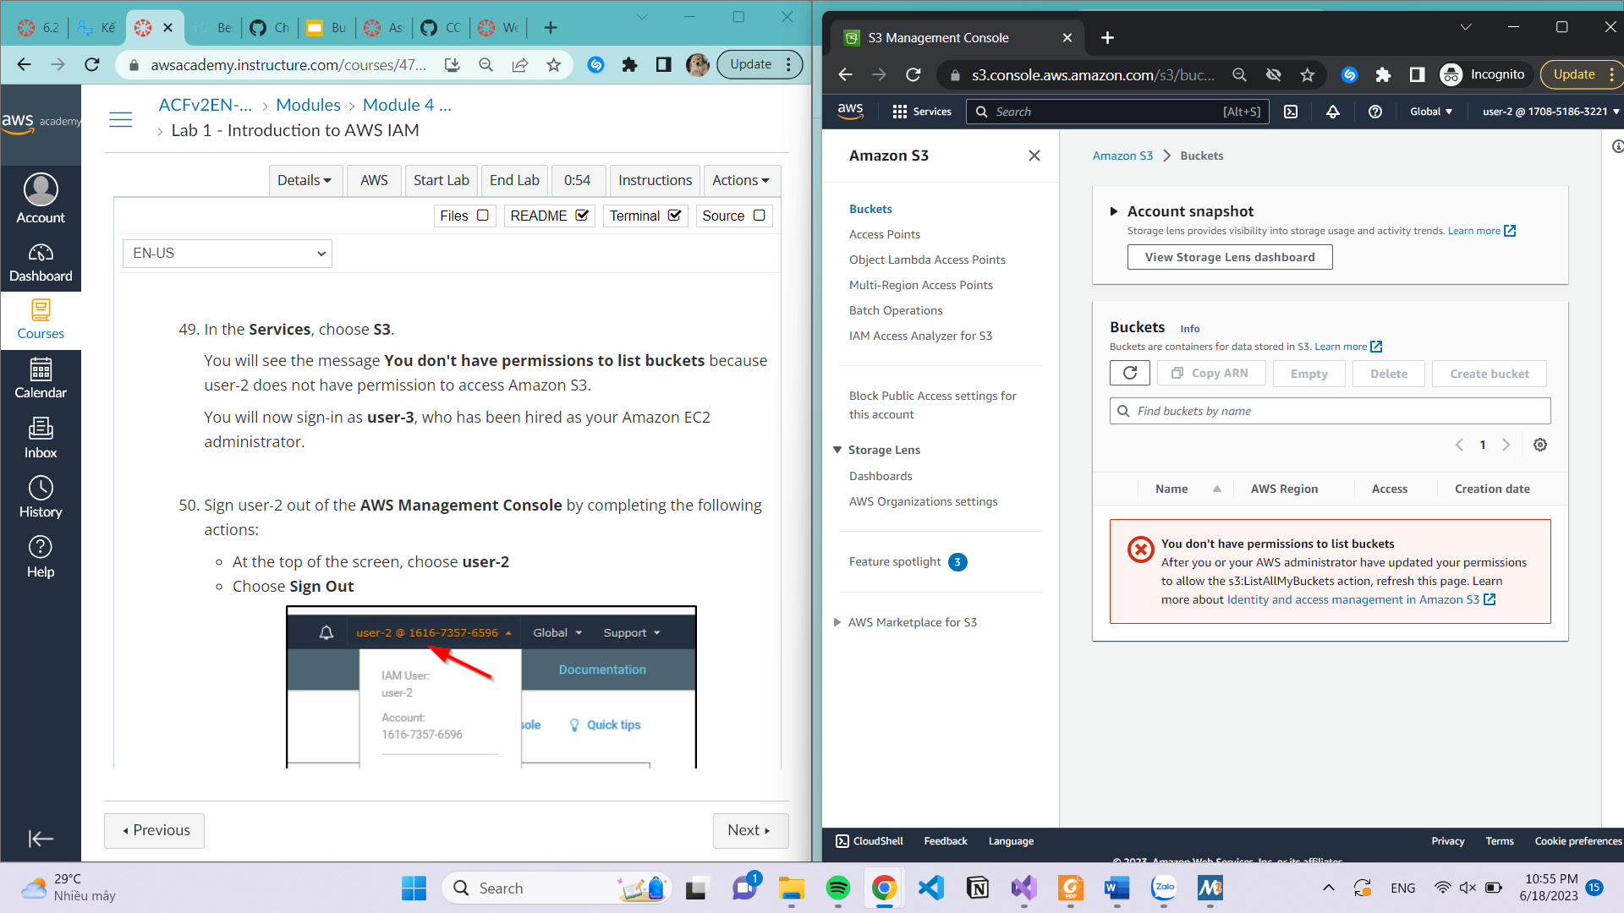

1. **Sign in as user-3**

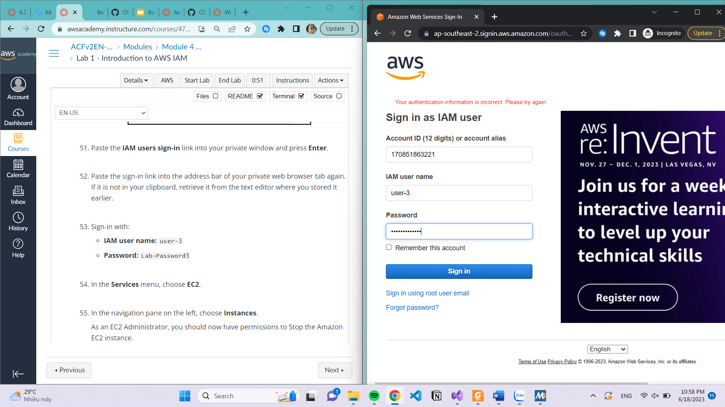

**Stop instance successful**

